Parent Resources

Scan the QR Code to access these helpful resources that are available for you.

Basic Computer Skills Copyright Piracy GED Classes

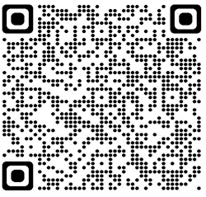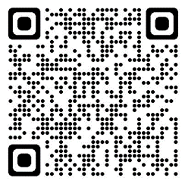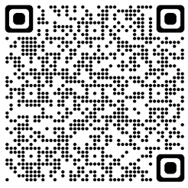

English as a Second Language Cellphone & Device Guide

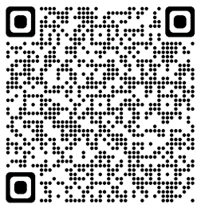 Classes (English & Espanol Flyer) for Parents

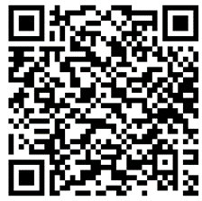

Don’t forget the Parent Resource Center is open in the media center. We have items ready for checkout to help support our students at home.

All parents and guardians of Targeted Assistance students at Dobbins Middle School have been invited to utilize the Parent Resource Center.

Contact Jamye Pierce, Instructional Lead Coach at [jpierce@paulding.k12.ga.us](mailto:jpierce@paulding.k12.ga.us) or 770.443.4835 ext. 24608